**Homework 3**

Liam Cain

Matt Marakovits

Paul McCusker

Zack Meath

Matt Musich

Login Screen:

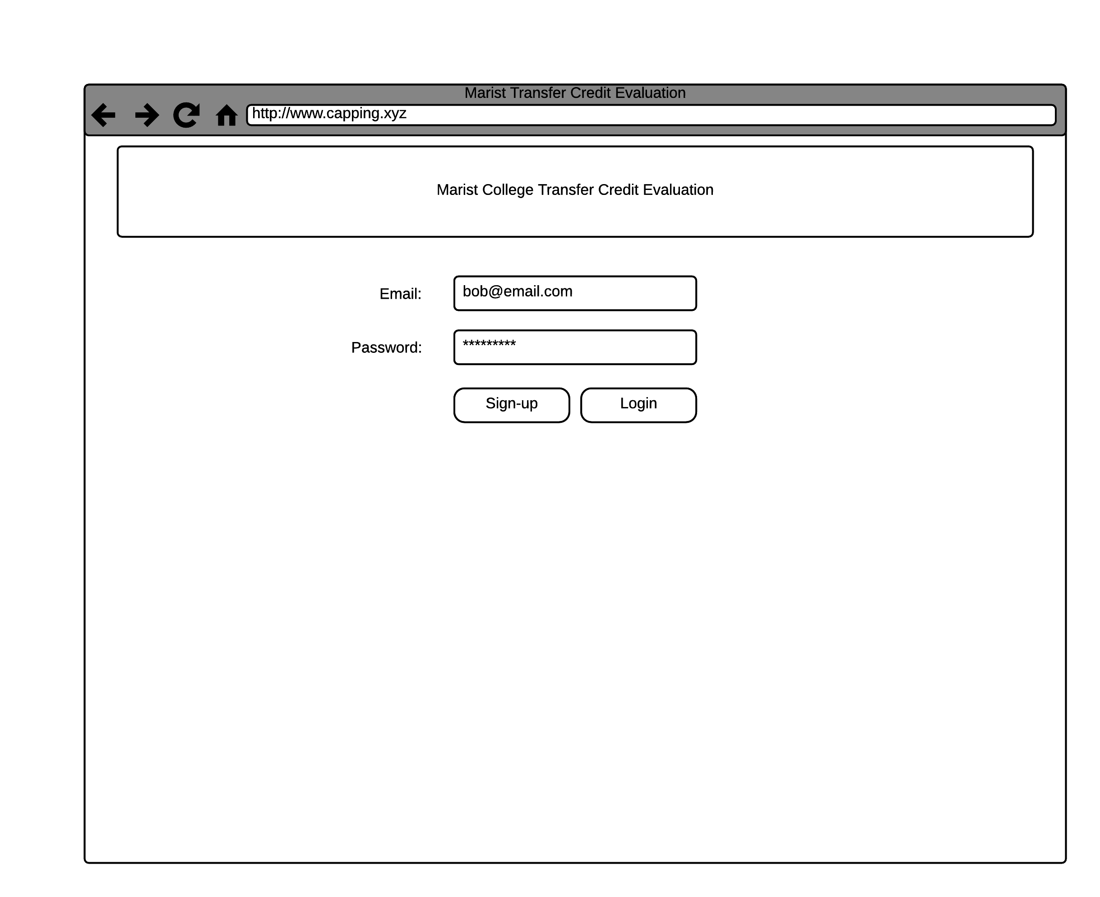

This is the page that the users will see when first accessing the website. As long as they have an account, they will be able to login with their email address and a password of their choosing. If they are given the student role, then they will be brought to the student view. Similarly, if the user has the role of admin, they will be brought to the admin view.

Student View:

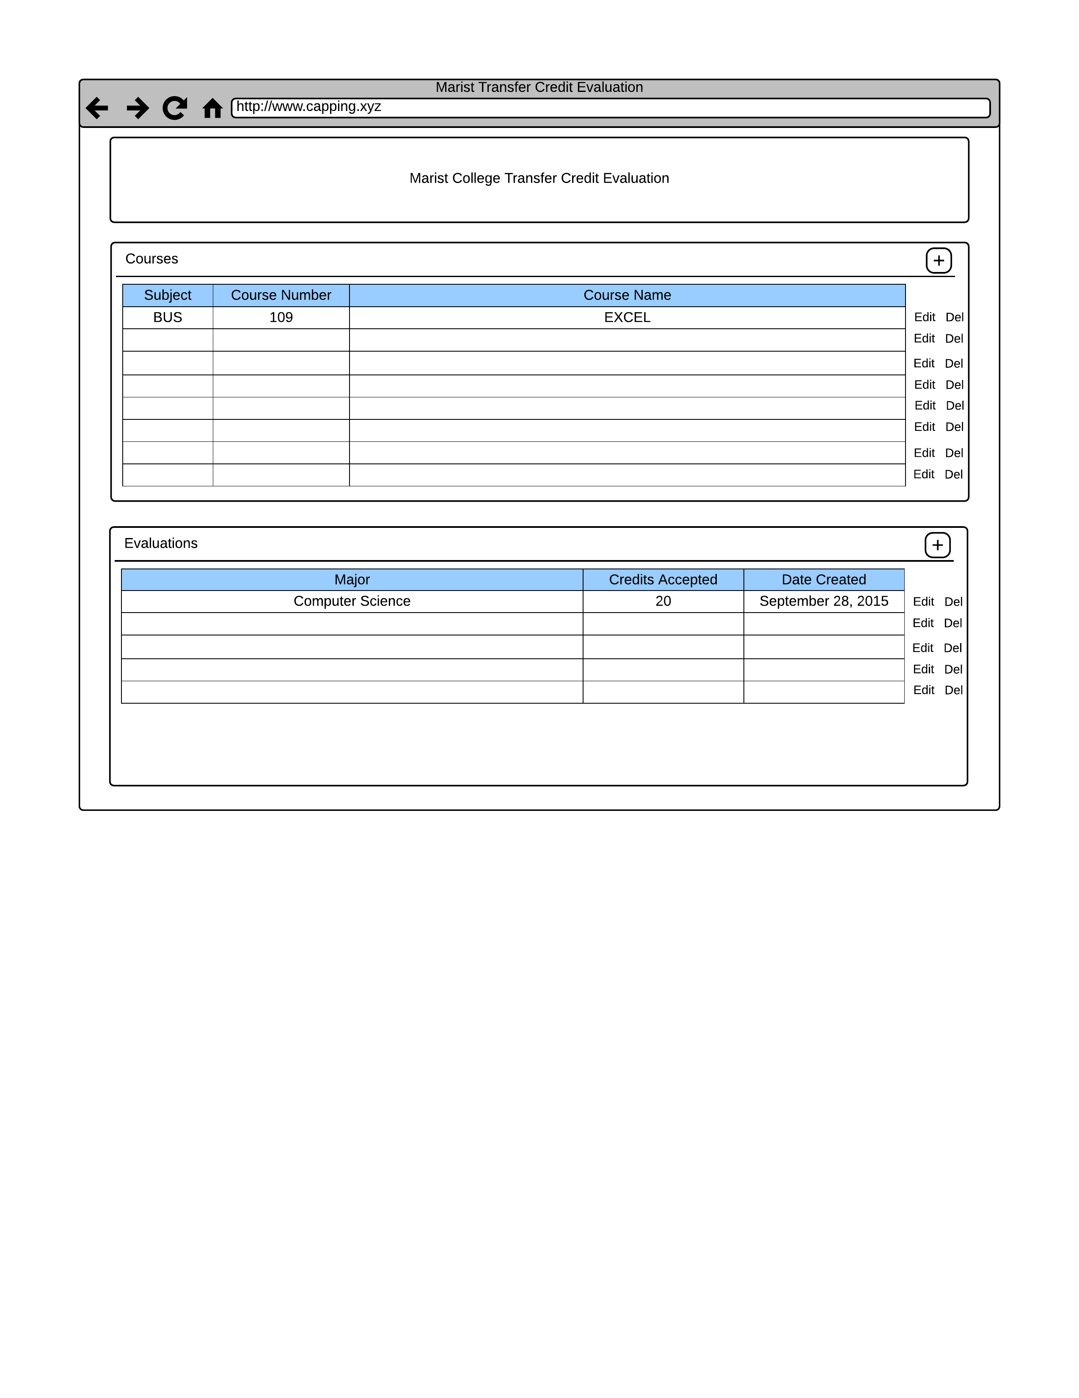

This is the student view of the credit evaluation system. What you see is all the classes that the student is currently taking at their respective college as well as any credit evaluations that they created. Using the edit and delete buttons, the student can edit or delete any existing credit evaluations or courses. Pressing the plus button under courses or evaluations will bring up a modal that will, respectively, allow the student to add a course or create a new evaluation.

Add a Course Modal:

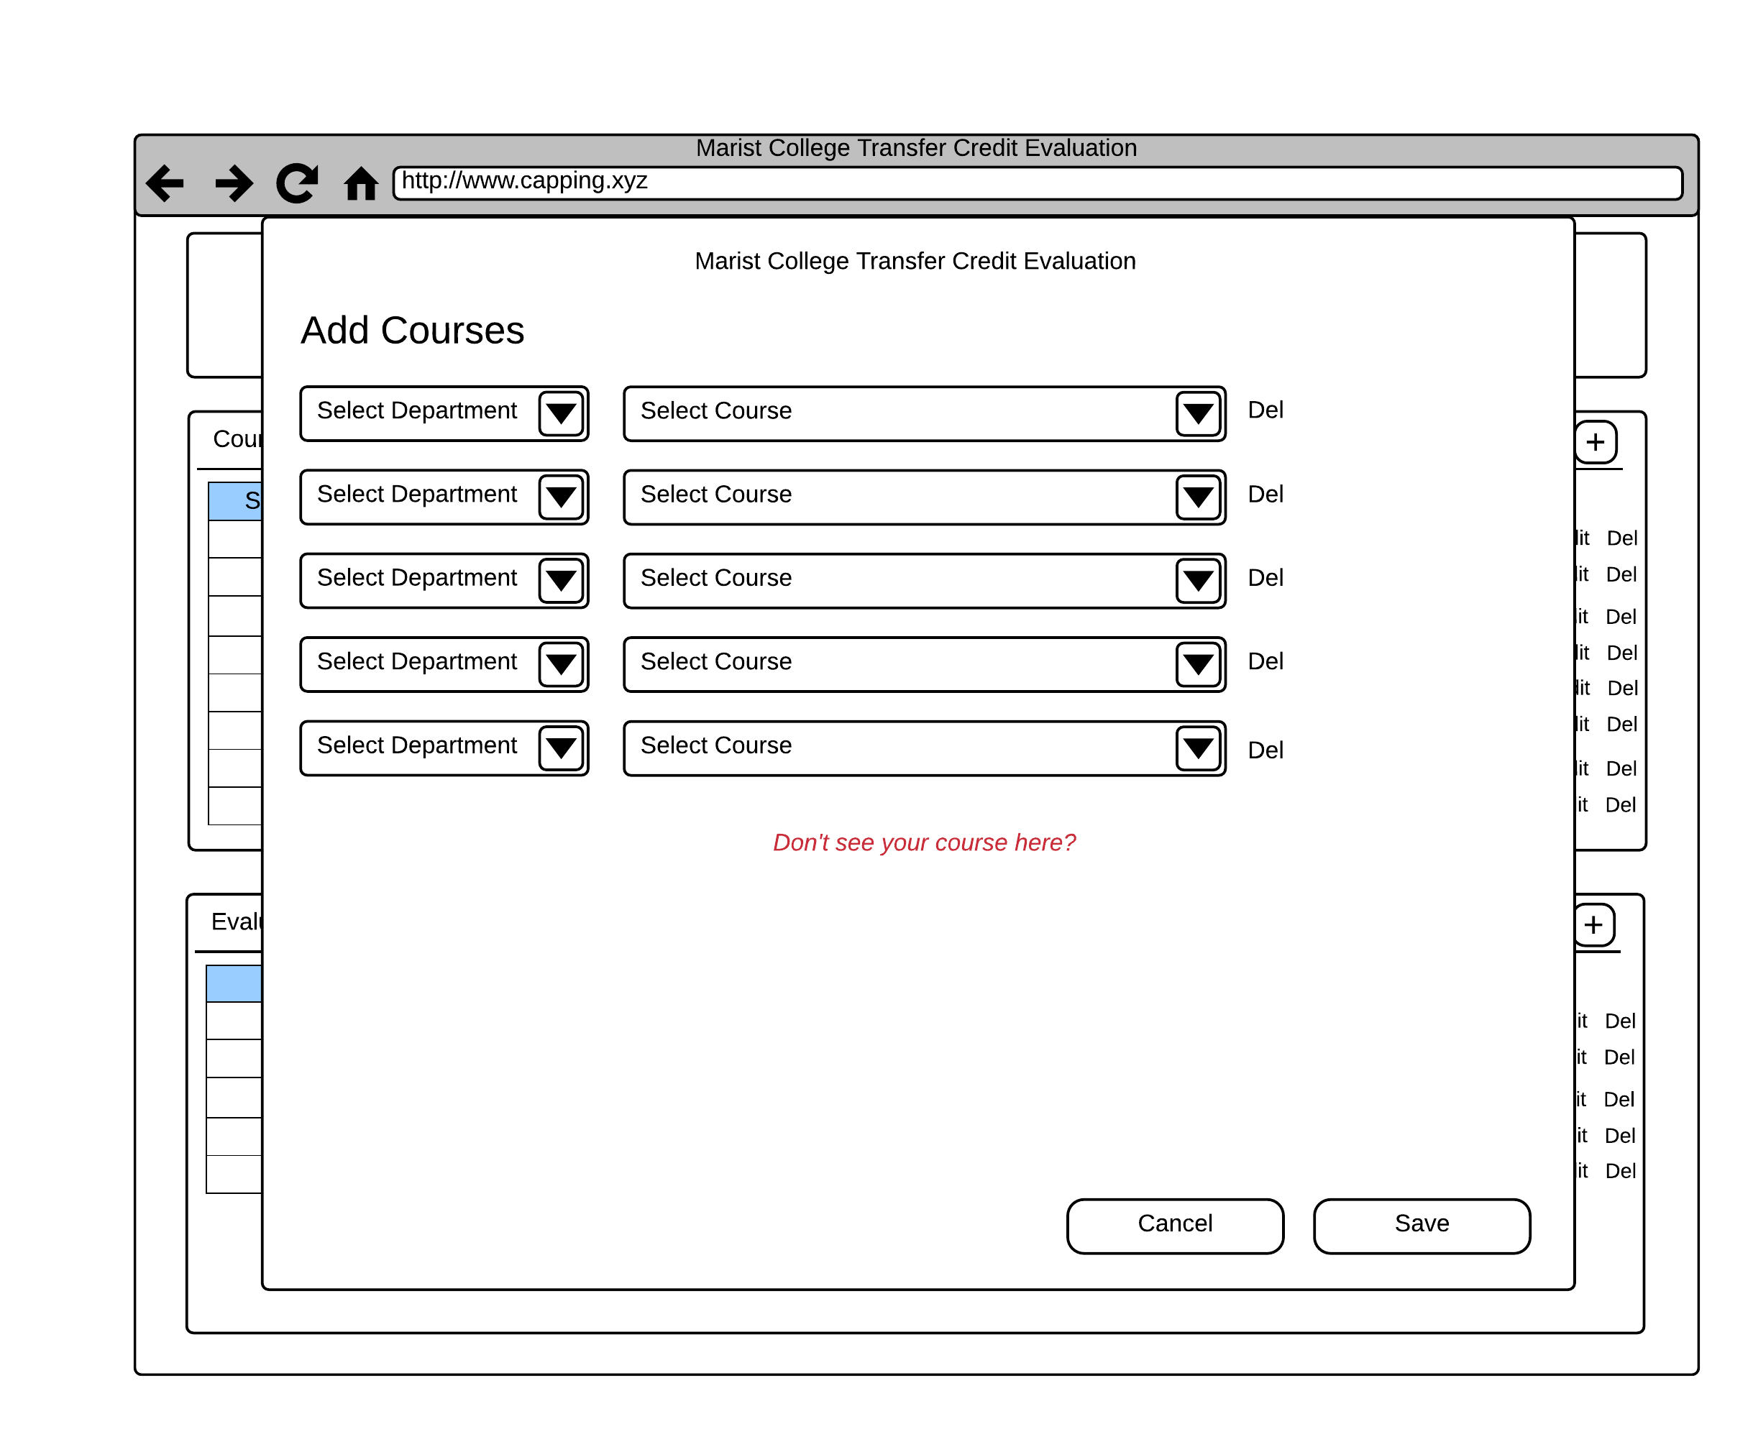

This is the add course modal. The student can select the department that their class is located it. This will narrow down the “select course” drop down box to only the courses within that department. Once all their courses are selected, the student hits save to save the listings. If a student selects five courses, more rows of drop downs will appear automatically. IF the course a student is looking for is not listed, they can click the “*Don’t see your course here?”* link to request it be evaluated.

Create New Evaluation Modal:

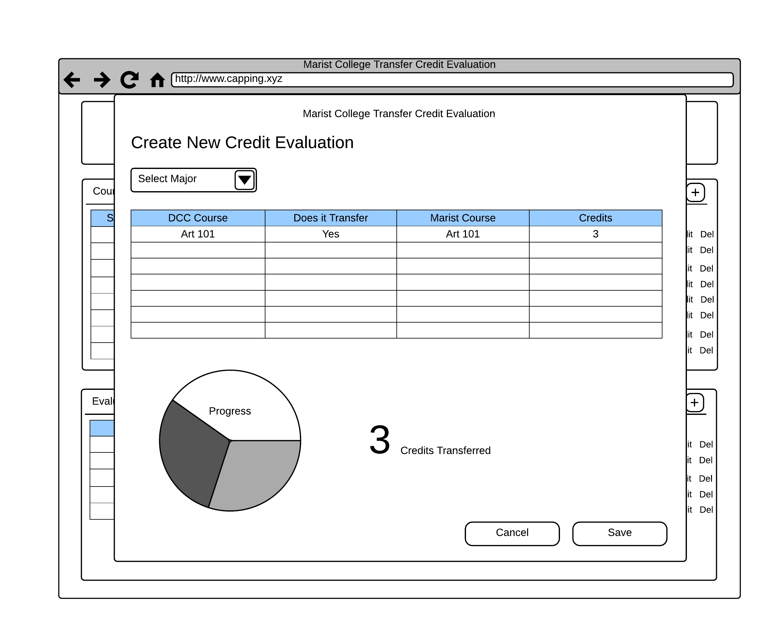

This is the modal for creating a new credit evaluation. What the student will do is select a major that Marist offers and they’ll be able to see a preview of the evaluation below it. There is also a graph showing them how many credits transferred versus how many didn’t transfer versus how many are still needed to complete the degree.

Administrator Page: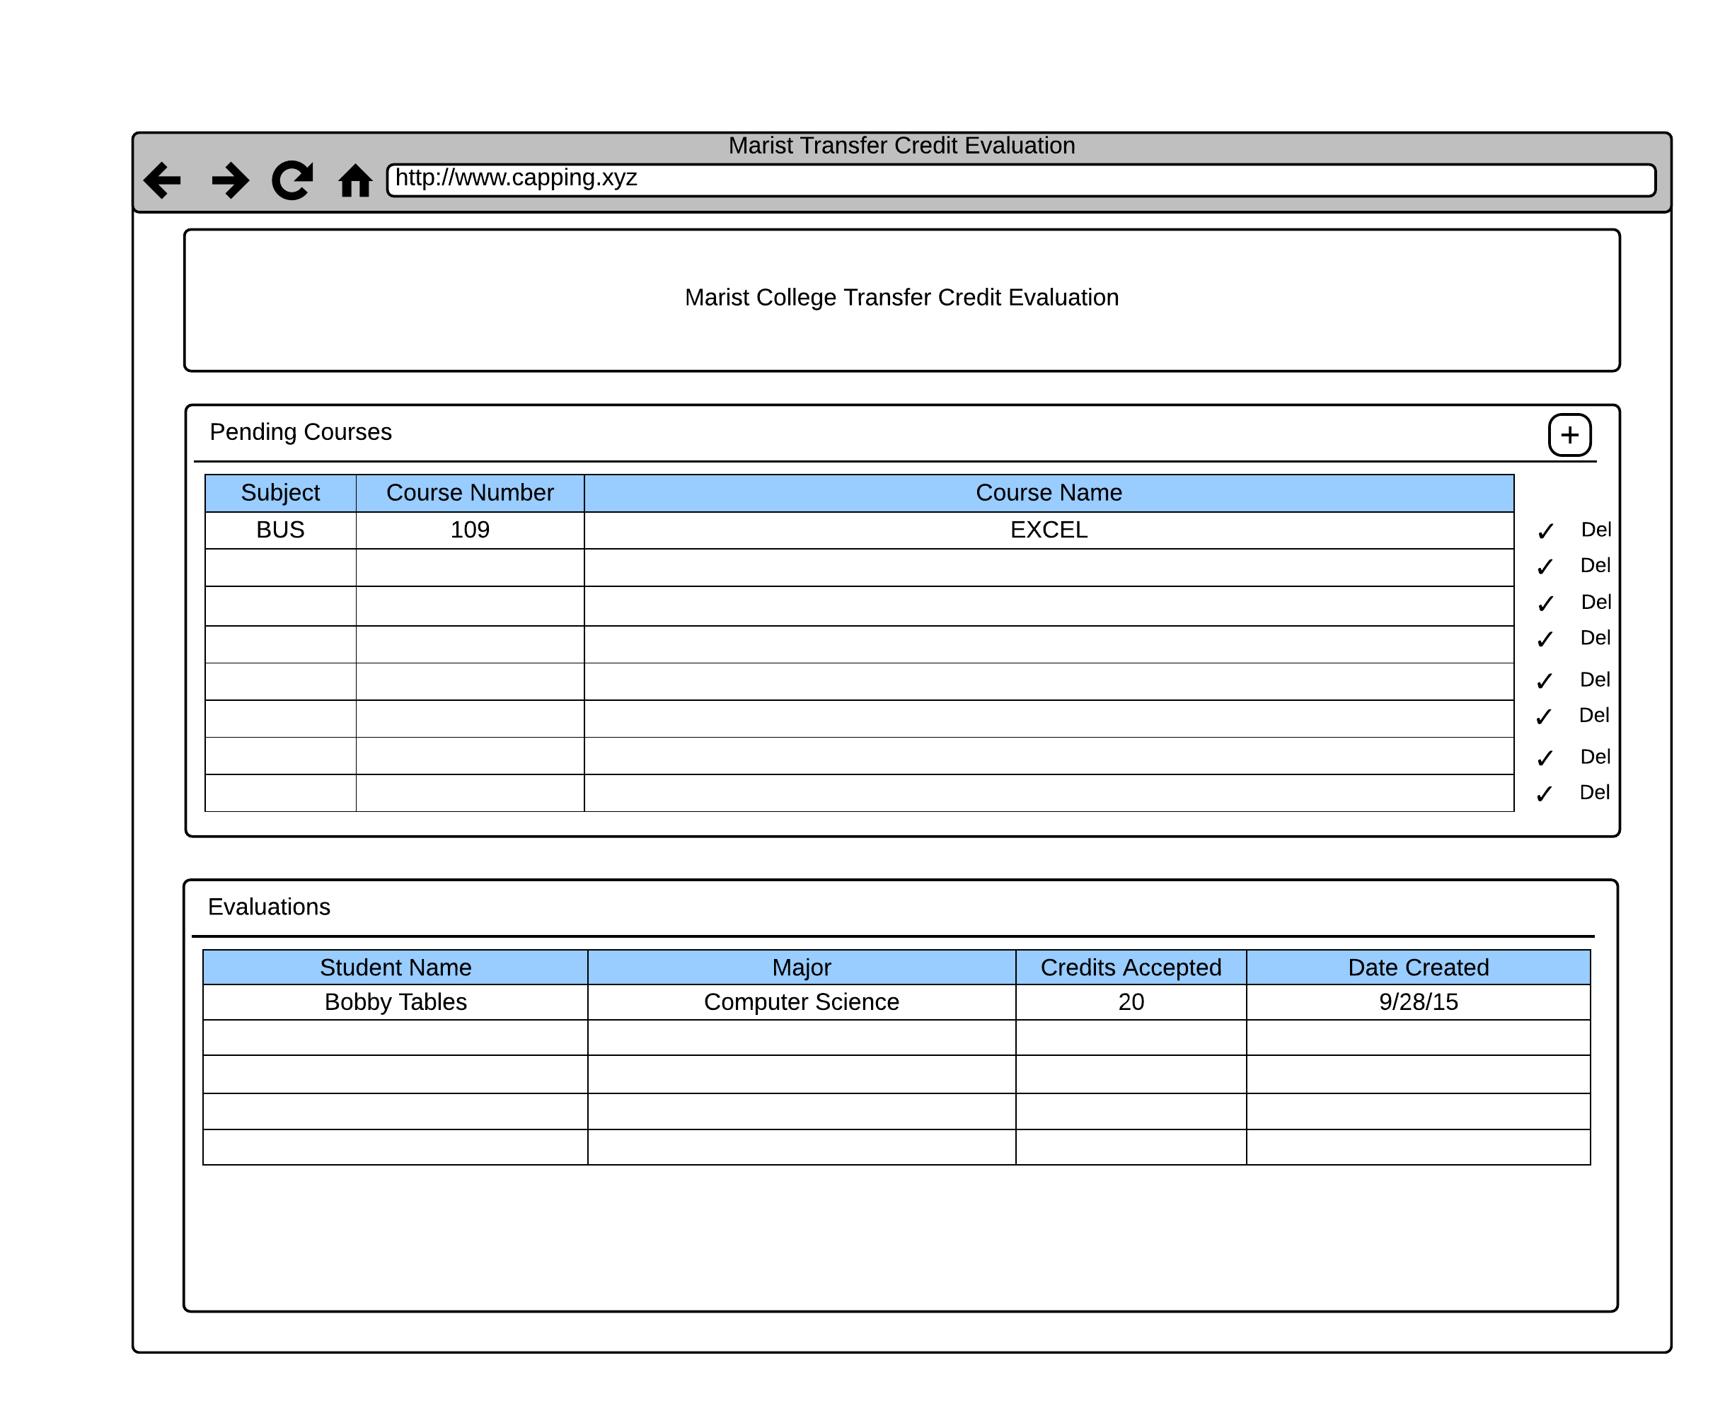

This is the view that the site administrator would see. They can see pending courses that students have requested and approve or deny them, as well as add new courses to the database using the plus button in the *Pending Courses* section. The administrator will also be able to view existing student evaluations.